//CS4370

//Parallel Programming for Many-Core GPUs

//Avery Colley

//Meilin Liu

//12/6/24

//Programming Assignment #4 -- Histogram

//Compiling command: nvcc Colley_Project4.cu -o histogram -arch=sm_30

Report:

My program has all of the functionalities required in the project description.

Global Memory with input array size of 131072:

Global Memory with input array size of 1048576:

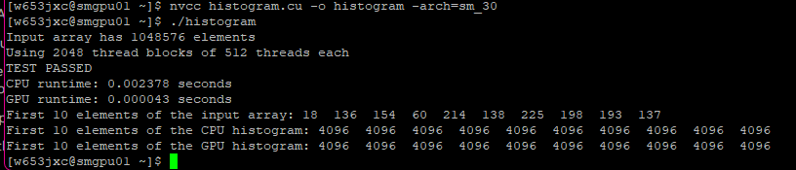

Shared Memory with input array size of 131072:

Shared Memory with input array size of 1048576:

